**Social Share Widget**

**Description**

The Social Share Widget offers the following features:

Share on Multiple Platforms: Users can share content on popular social media platforms such as Facebook, LinkedIn, Twitter, WhatsApp, and via email.

Customizable Buttons: Each share button is accompanied by an icon representing the respective social media platform. The icons can be customized in terms of size and appearance to match your application's design.

User-Friendly Interface: The widget presents a user-friendly interface, featuring a "Share" button that, when clicked, reveals a set of share icons. Users can choose their preferred platform and share the content seamlessly.

**Typical Usage Scenario**

When a user clicks on the share button, the Social Share Widget opens up a selection of popular social media platforms, including Facebook, WhatsApp, LinkedIn, andemail, allowing users to easily share the link through these platforms. This seamless integration empowers users to reach a wider audience by sharing the URL through their preferred channels, enhancing engagement and expanding the reach of the shared link.

**Prerequisites**

NA

**Features and Limitations**

Sharing URL in social media.

**Dependencies**

Require Mendix 9.24.0 or above.

**Installation**

When a user clicks on the share button, the Social Share Widget opens up a selection of popular social media platforms, including Facebook, WhatsApp, LinkedIn, and email, allowing users to easily share the link through these platforms. This seamless integration empowers users to reach a wider audience by sharing the URL through their preferred channels, enhancing engagement and expanding the reach of the shared link.

**Styling**

To enhance the visual appeal of the Social Share Widget, you can customize the CSS styles in the provided SocialShare.css file. Adjusting the styles of the button container, share button, close button, close icon, and share icons will allow you to align the widget's appearance with your application's design.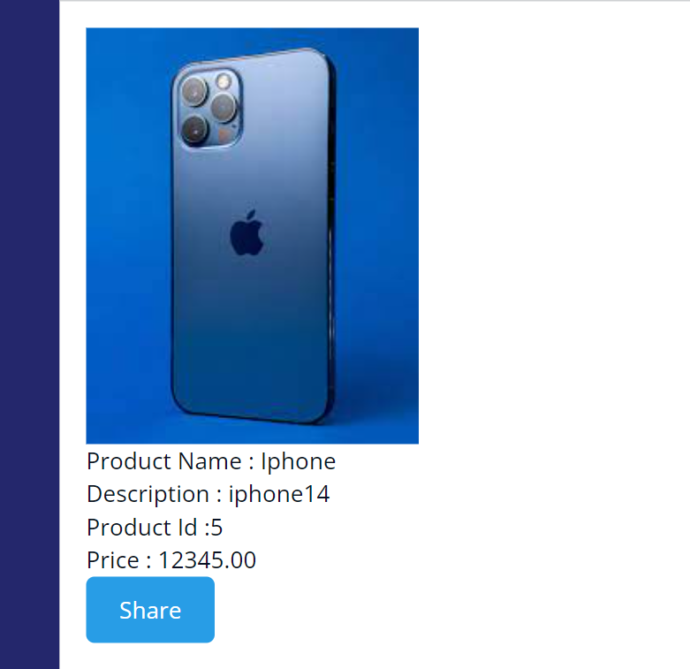

**Configuration: NA**

**Category: Module**

**Subcategory: All**

**Visibility: Public Marketplace**

**Studio Pro Version: 9.24.0**